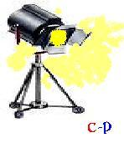 Centerpiece-Presentations

Release of Liability

For any acts involving property
Presented for usage as still or in motion props

I ___________________, Release Centerpiece-Presentations.com / Centerpiece-Presentations , and the agents, servants and successors of Centerpiece-Presentations.com / Centerpiece-Presentations , from all claims of any kind whatsoever from the (date) _________________ of the execution of this release. From any and all liability for any damage that my property may incur, during the commission assignment of which I present my property, and related usages.

I_________________ agree any liability claims will be handled between (me) ____________ and the contracting party who engages the personal and sole personal usage of my Property.

Signature ____________________________ Date: ____________________

