Centerpiece-Presentations
Presentaing
“The Centerpiece Marketplace”
L.L.C.
Start Your Own Business
Join in as a Vendor Seller
“It’s Simple”
Rent A Booth, Market Your Products, Arts and Crafts, Personal Designer Goods, Commercial Goods, Automotive What ever your Business Desire is, Market your Services, and More.

Together We Will Rebuild Our Economy and Create New Merchants from The Efforts of Our Residents

Your Opportunity Has Arrived

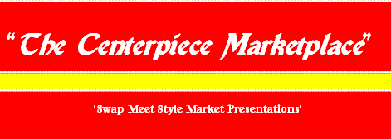
Swap Meet Style Market Setting

Coming to Shreveport
The State Fair Grounds

Dec 6 -7th & 20-21st

Register Now !
www.centerpiece-presentations.com
Downloadable forms

For More Information

Phone 318-734-3342 / 318-734-0057

 | Centerpiece-Presentations  6007 Financial Plaza - Suite 714  Shreveport, LA. 71129

