
Centerpiece-Presentations
“Food & Beverage Server”
Vendor Permit

Display Always a Sense of Responsibility
“We assume NO Liability for any Food Server acts or action, quality or any element of their provision of food and beverage. No exception”
This entitle you as an Individual Seller to participate in
Centerpiece-Presentations “Swap Meet” an
Enterepenurial Opportunity as a Participating Vendor Seller

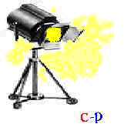

An Experience in Commercial- and Community Service

Centerpiece-Presentations – this warrants Only as a Seller Permit, No other benefit or obligation is assummed nor Implied. We assume No Liabiiity in or of your actions and expect you to abide by the swap meet guidelines | Swap Meet  516843-FB  Food/Beverage | Alonzo Smith
Issued June 25, 2008
Expires: Wednesday, June 25, 2008

